Creating a Monster Mask using GIMP

1. Open Gimp
2. In the top menu, click on “file” then “open”, then open either “start-with-jackolantern” or “start-with-skeleton”.
3. Here’s the tricky part, open the folder called “decorations” so that you can see your Gimp window behind it.
4. Now click and drag any decoration of your choice into the Gimp window, then release the mouse button.
5. Now that your decoration should appear over top of your skelton or jack-o-lantern face.
6. Now select the move tool, and using your mouse, move the decoration to where you would like it to be.
7. The move tool looks like this 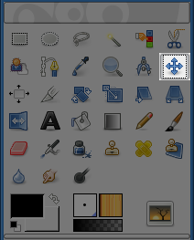
8. Repeat steps 3 to 6 until you are happy with your creation.
9. If you want to rearrange or delete any of the decorations, you can do this by selecting the appropriate layer in the layer box (this is usually on the right side of the screen)
10. 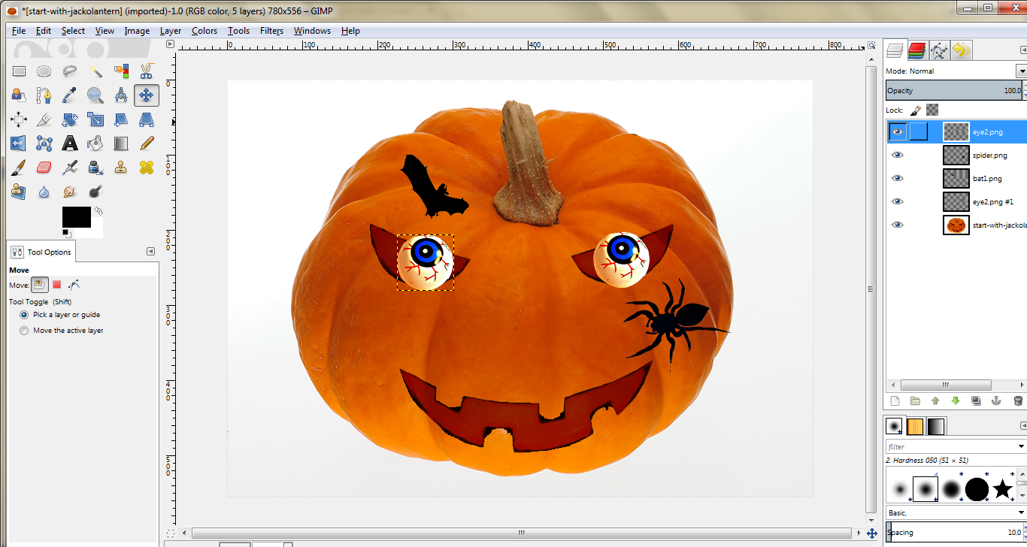Here you can see that I have selected the layer for the left eyeball.
11. Once you have the proper layer selected, you can:
    1. delete it by clicking the trash can icon in the layers box. or
    2. move it by choosing the move tool and clicking and dragging it to the right spot.
12. When you are happy with your creation, you can save it by going to the top menu, clicking on “file”, then “save as”, and choosing a place on your computer to save it.
13. I would recommend that you save it first as a .xcf file, so that you can edit your creation later. Then save it as a .jpg so that you can share it easily.